Name: Muhammad Uzair

Roll No. L1F18BSCS0311

Section: H

Database Lab 8

CREATE TABLE user (

`id` smallint(5) unsigned NOT NULL AUTO_INCREMENT,

`name` varchar(30) NOT NULL,

`course` smallint(5) unsigned DEFAULT NULL,

PRIMARY KEY (`id`)

);

insert into user values (1, 'Alice', 1);

insert into user values (2, 'Bob', 1);

insert into user values (3, 'Caroline', 2);

insert into user values (4, 'David', 5);

insert into user values (5, 'Emma', NULL);

select * from user;

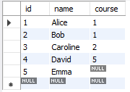

CREATE TABLE `course` (

`id` smallint(5) unsigned NOT NULL AUTO_INCREMENT,

`name` varchar(50) NOT NULL,

PRIMARY KEY (`id`)

);

insert into course values (1 ,'HTML5');

insert into course values (2 ,'CSS3');

insert into course values (3 ,'JavaScript');

insert into course values (4 ,'PHP');

insert into course values (5 ,'MySQL');

select * from course;

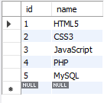

ALTER TABLE `user`

ADD CONSTRAINT `FK_course`

FOREIGN KEY (`course`) REFERENCES `course` (`id`)

ON UPDATE CASCADE;

SELECT user.name, course.name

FROM `user` INNER JOIN `course`

on user.course = course.id;



SELECT user.name, course.name

FROM `user` LEFT JOIN `course`

on user.course = course.id;

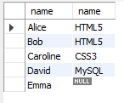

SELECT user.name, course.name

FROM `user` RIGHT JOIN `course`

on user.course = course.id;

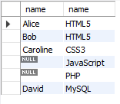

SELECT user.name, course.name

FROM `course` LEFT JOIN `user` on user.course = course.id;

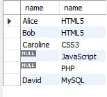

SELECT course.name, COUNT(user.name)

FROM `course` LEFT JOIN `user`

ON user.course = course.id

GROUP BY course.id;

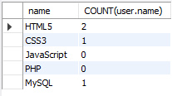

SELECT user.name, course.name

FROM `user` LEFT JOIN `course`

on user.course = course.id

UNION

SELECT user.name, course.name

FROM `user` RIGHT JOIN `course`

on user.course = course.id;

